### Class 21CLC – Term III/2022-2023

### Course: CSC14003 – Artificial Intelligence

Homework 01

***Submission Notices:***

* *Conduct your homework by filling answers into the placeholders given in this file (in Microsoft Word format). Questions are shown in black color, instructions/hints are shown in italic and blue color, and your content should use any color that is different from those.*
* *After completing your homework, prepare the file for submission by exporting the Word file (filled with answers) to a PDF file, whose filename follows the following format,*

*<StudentID-1>_<StudentID-2>_HW01.pdf (Student IDs are sorted in ascending order)*

*E.g.,* ***1852001_1852002_HW01.pdf***

*and then submit the file to Moodle directly WITHOUT any kinds of compression (.zip, .rar, .tar, etc.).*

* *Note that you will get zero credit for any careless mistake, including, but not limited to, the following things.*
  1. *Wrong file/filename format, e.g., not a pdf file, use “-” instead of “_” for separators, etc.*
  2. *Disorder format of problems and answers*
  3. *Conducted not in English*
  4. *Cheating, i.e., copy other students’ works or let the other student(s) copy your work.*

**Problem 1. (2pts)** Give aPEAS description for each of the following activities

1. A tailor is sewing clothes on the sewing machine.

*Please write your answer in the following table.*

|  |  |
| --- | --- |
| Performance measure | Sewing clothes correctly and beautifully |
| Environment | A tailor,  Sewing machine,  Clothes,  Sewing kits |
| Actuators | Hand (to control the sewing machine),  Scissors (to cut the unused clothes) |
| Sensors | Eyes (to identify which area in the clothes need to be sew),  Human body (to combine body’s part)  Ruler (to calculate the distance to sew clothes) |

1. A customer is ordering food on GrabFood by using his smartphone.

*Please write your answer in the following table.*

|  |  |
| --- | --- |
| Performance measure | Ordering food correctly and successfully |
| Environment | A customer,  A smartphone connecting wife,  GrabFood app, |
| Actuators | Hand (to use smartphone and click on the screen), |
| Sensors | Eyes (to see information on smartphone), |

**Problem 2. (0.5pt)** While appreciating the great contribution of AI to practical life, it is also noteworthy that there are several AI applications designed for shady purposes. Describe an AI application that you think it may have bad effects to our lives and state your opinions.

*Briefly describe the “shady” AI application.*

|  |
| --- |
| Autonomous Weapons : These are weapons that can operate without human intervention, using AI algorithms to identify and engage targets. |

*State your opinion why it is “bad”.*

|  |
| --- |
| The use of autonomous weapons is mostly to do harm to everyone. Also, it raises several ethical and safety concerns. For example, there is the risk that these weapons could malfunction or be hacked, causing them to target the wrong people or engage in inappropriate behavior. Additionally, there is the possibility that these weapons could be used by malicious actors, such as terrorists or rogue states, to carry out attacks without any human oversight or intervention. |

**Problem 3. (1.5pts)** *The wolf, goat, and cabbage problem*. Once upon a time a farmer went to a market and purchased a wolf, a goat, and a cabbage. On his way home, the farmer came to the bank of a river and rented a boat. But crossing the river by boat, the farmer could carry only himself and one of his purchases: the wolf, the goat, or the cabbage. If left unattended together, the wolf would eat the goat, or the goat would eat the cabbage. The farmer's challenge was to carry himself and his purchases to the far bank of the river, leaving each purchase intact.

Formulate the above problem as a search problem by answering the following questions.

* How do you represent a state? That is, which elements are included in a single state and what is the range of value for each element? (0.5pt)

|  |
| --- |
| Let’s represent two sides of the river is side A (initial side of the river) and side B (goal side of the river).  Each state can be represented by 4 elements which are : location of Farmer, location of Wolf, location of Goat, location of Cabbage.  The state is formulated as :**{ <location of Farmer>, <location of Wolf>, <location of Goat>, <location of Cabbage>}.**  The range of each element is in {A, B} |

* How many states are there in state space? Justify your answer. (0.5pt)

|  |
| --- |
| There are 2*2*2*2 = 16 states. Because each element has 2 options {A, B} which represents the side of the river (side A or side B). |

* Draw a directed acyclic graph (DAG) of the state space. Mark the optimal solution. (0.5pt)

|  |
| --- |
| A picture containing diagram, line, plot, screenshot  Description automatically generated  Link image of graph for clear view: https://drive.google.com/file/d/1yTn6hrkIv9BtCCdwQlu39ubf_nfT1RLN/view?usp=sharing |

**Problem 4. (1pt)** Consider the following 8-puzzle initial state (a) and goal state (b).

|  |  |  |  |  |  |  |  |  |  |  |  |  |  |  |  |  |  |  |  |  |  |  |
| --- | --- | --- | --- | --- | --- | --- | --- | --- | --- | --- | --- | --- | --- | --- | --- | --- | --- | --- | --- | --- | --- | --- |
| |  |  |  | | --- | --- | --- | | 2 | 8 | 3 | | 1 | 6 | 4 | | 7 |  | 5 | | (a) |  | |  |  |  | | --- | --- | --- | | 1 | 2 | 3 | | 8 |  | 4 | | 7 | 6 | 5 | | (b) |

Apply A* using Manhattan distance heuristic function.

* Draw the search tree including possible expanded states during the algorithm procedure.
* Compute the triple (g, h, f) for each state. Mark the optimal strategy found.

*Hint: How does an 8-puzzle search tree look like? Use Excel or PowerPoint to draw, for example,*

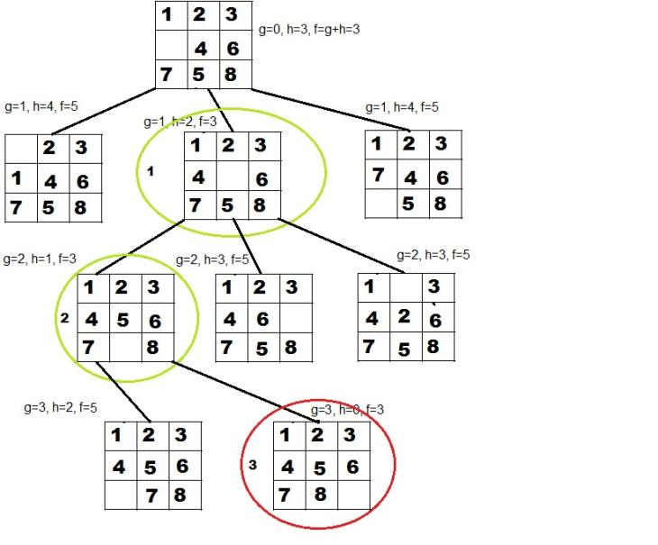

Link excel for clear view : https://docs.google.com/spreadsheets/d/1R0I8CSWuWsDB15d6f4QRJx5M1MKYG8oy/edit?usp=sharing&ouid=106521145644465357325&rtpof=true&sd=true

|  |  |
| --- | --- |
| **Problem 5. (2.5pts)** Consider a delivery robot world with mail and coffee to deliver.  Assume a simplified domain with *four locations* as shown aside. This domain is quite simple, yet it is rich enough to demonstrate many of the problems in representing actions and in planning. |  |

The robot, called Rob, can *pick up coffee* *at the coffee shop, pick up mail in the mail room, move, and deliver coffee and/or mail*.Delivering the coffee to Sam's office will stop *Sam from wanting coffee*.There can be *mail waiting at the mail room* to be delivered to Sam's office.

Rob can *move clockwise (mc)* or *move counterclockwise (mcc)*. Rob can *pick up coffee (puc)* if Rob is at the coffee shop and it is not already holding coffee. Rob can *deliver coffee (dc)* if Rob is carrying coffee and is at Sam's office. Rob can *pick up mail (pum)* if Rob is at the mail room and there is mail waiting there. Rob can *deliver mail (dm)* if Rob is carrying mail and at Sam's office. Assume that it is only possible for Rob to do one action at a time.

Formulate the task above as a search problem by determining the primary concepts.

*Please write your answer in the table*

|  |  |
| --- | --- |
| **Search concepts** | **Descriptions** |
| (0.5pt) Representation for a state | The states are the quintuples specifying the robot's location, whether the robot has coffee, whether Sam wants coffee, whether mail is waiting, and whether the robot is carrying the mail. |
| (0.5pt) State-space graph: how many states there are and how they connect together | There are 4*2*2*2*2= 64 states. |
| (0.5pt) Set of actions | There are six actions, (mc, mcc, puc, dc, pum, dm). |
| (0.5pt) Transition model | The complete problem representation includes the transitions for the 64 states. |
| (0.5pt) Path cost | Because the problem description does not mention the cost for each move so assume each action costs 1 |

|  |  |
| --- | --- |
| **Problem 6. (2.5pts)** Consider the following graph. The start and goal states are **S** and **G**, respectively.  For each of the following **graph search** strategies, work out order in which states are expanded, as well as the path returned. In all cases, assume ties resolve in such a way that *states with earlier alphabetical order are expanded first*. Remember that in graph search, a state is expanded once. |  |

1. Depth-first search (0.5pt)
2. Breadth-first search (0.5pt)
3. Uniform cost search (0.5pt)
4. Greedy best first search with the heuristic *h* shown on the graph (0.5pt)
5. A* search with the same heuristic (0.5pt)

*Note that:*

* Tree-search DFS avoids repeated states by checking new states against those on the path from the root to the current node.
* For DFS, BFS, and GBFS, the goal test is applied to each node when it is generated rather than when it is selected for expansion.

*Please write your answer in the table*

|  |  |  |
| --- | --- | --- |
| **Algorithms** | **List of expanded states (in exact order)** | **Path Returned** |
| DFS | S, A, B, D | S,A,D,G |
| BFS | S,A,B,C | S,C,G |
| UCS | S,B,A,C,G | S,C,G |
| GBFS | S,B,C | S,B,C,G |
| A* | S,B,A,C,G | S,C,G |